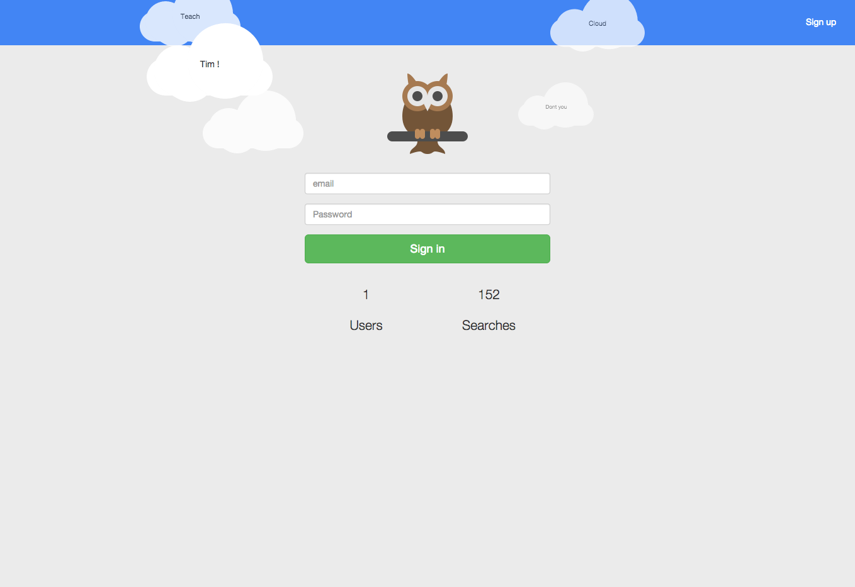

**Glossary of Terms**

**Assumptions**

**Project Drivers**

**The purpose of the project**

**The Goals**

**The Stakeholders**

**Project Constraints**

**Mandated Constraints**

**Solution Constraints**

**Implementation Environment Constrainsts**

**Partner or Collaborative Applications**

**Schedule Constraints**

**Budget Constraints**

**Relevant Facts and assumptions**

**Business Rules**

**Functional Requirements**

**The Scope of the Work**

**Context Diagram**

**Work Partitioning**

**Business Use Cases**

**Business Data Model**

**Data Model**

**The Scope of the Product**

**Functional Requirements**

**Non-functional Requirements**

**Appearance and style**

**Responsiveness**

**Personalisation and Internationalisation**

**Accessibility**

**Speed and latency (Performance)**

**Reliability and availability**

**Capacity**

**Maintainability and support**

**Ease of use**

**Learning**

**Security**

**Database design:**

**Modeling and prototyping**

**User Interface**

**Mobile design**

**Code implementation**

**Website design - HTML and CSS**

**JavaScript**

**PHP and SQL**

**External code implementation**

**Code testing**

**Work organization**

**Project progress**

**Project issues and solutions**

**Learning outcome and final conclusions**

**Appendix:**

Executive summary

Introduction

Coming from my research phase of my project i had to design a project that would explain all the research that i had to do in the first semester. From here i decided to develop a metasearch engine that will help me to implement im theories into practice. In this documentation i will go through the design of my project and why i decided to the thing in the way i picked.

The Goals

The application should work searching multiple search engines though apis. .

The application will be put on Raspberry Pi .

The application will allow for search engines to organise in an orderly fashion.

* ● sign up/log in and profile
* ● SearchBar / with statistics.
* ● Searching multiple search engines e.g bing/instagram/google/goduck/Results being organised
* Users will be able to log on the website with their username and password.If they do not have username and password they have to go on the signup page and create one. Here the data is added to the database where they can log into in the future.
* Once logged on they can users can input search results into a search bar and below the search results will appear in an orderly fashion.
* After this user would be able to click the settings page here they will be able to change the setting such as passwords. They will also be able to delete their account and choose to add their results to twitter or not. Users will also have the ability Go go on the statistics page They will be able to see what is the most popular searches that are made. All the searches will be stored in the database for the ability to rank them in the statistics page.

The Stakeholders

Visitors

For Google, a visitor is a search visitor who is not logged into gmail or any other google service. If my grandmother went on a computer and searched for “Greek Wine” using Google’s search toolbar at Google.com, she would be a visitor. - See more at: <http://guidedlaunch.com/blog/2012/internet-user-defined/#sthash.J74y0xQL.dpuf>

Users

a visitor who registers their identity with your website through your own registration process or through an Facebook or Open ID interface. - See more at: <http://guidedlaunch.com/blog/2012/internet-user-defined/#sthash.J74y0xQL.dpuf>

Developer

A **web developer** is a programmer who specializes in, or is specifically engaged in, the development of World Wide **Web** applications, or distributed network applications that are run over HTTP from a **web**server to a **web** browser.



9

**Design & implementation**

**Detail your design (why did you do it this way?)**

There is going to be quite a view different types and level of design I am going to write about here but i have to ask myself that if i don't challenge my self to create a visual design for our users that synthesizes the classic principles of good design with the innovation and possibility of technology and science. What is the point. This is about brought me to material design. So in the following I am going to talk about the database design the use and choice of material design for the overall look and feel. Lets begin.

**Database Design**

For the design specification i talked about earlier in the document, I had to design the a database that had to follow the major steps in database design I learnt in my time in cit.

So I designed a developed application to store and maintain information about the users and their activities while searching the web though my meta search engine. The tables to be properly functional need to comply with the third normal form. To do this i used high level approach to the matter of the subjects, to whose i applied the following:

* Think of the entities as a self containing units
* Discover attributes based on the requirements
* Apply known methods to improve functionality
* Follow table design rules up u to the 3NF

For a refresher for new users the steps to follow are:

Normal forms for tables design



**1NF:**

Contains only atomic values

There are no repeating groups

Primary key is set.



**2NF:**

Is in first normal form

All non­key attributes are fully dependant on the primary key (no partial dependencies).



**3NF:**

Is in second normal form

All non ­primary fields are dependant on the primary key (no transitive dependencies).

**Users table.**



**This table is going to store the details of the user that will be allowed to use the application. Initially I had two sets of users whose details will be stored (later admin, basic user). As I spot that the attributes of each set are shared and only level of privileges will differentiate between them, i decided to make it a one type of user as it is an open source search engine with no Admin of control by design. I also agreed on the meaning of the values stored by this field which are:**

|  |  |  |  |  |  |
| --- | --- | --- | --- | --- | --- |
| **Id** | **name** | **email** | **password** | **twitter** | **Status** |
| **1** | **Tadhg** | **Tadhg@tadhg.com** | **Tadhg** | **0** | **0** |

**As talked about earlier I wanted to make this more bamfy and open source so I decided by design to remove user privileges. So I removed the Status column.**

|  |  |  |  |  |
| --- | --- | --- | --- | --- |
| **Id** | **name** | **email** | **password** | **twitter** |
| **1** | **Tadhg** | **Tadhg@tadhg.com** | **Tadhg** | **0** |
|  |  |  |  |  |
|  |  |  |  |  |

**Search Tables**

This table at its heart is to collect and store information on what the user searches and stores the date so I can build top searches in different area codes (these hoes).

The userid in the users table (primary) and userId in the search table creates the link between the two for quick and easy searches. I also added time,date,location,search term.Further revision discovered redundancy of the userId which i had twice column as for the most cases. Final inspection for this table removes id field and permission.This applies to other tables, as I will further see there is no need for additional field when set of existing fields can act as composite primary key.

|  |  |  |  |  |  |
| --- | --- | --- | --- | --- | --- |
| Id | Searchterm | Userid | date | time | location |
|  |  |  |  |  |  |

|  |  |  |  |  |
| --- | --- | --- | --- | --- |
| Userid | **SearchTerm** | **Date** | **Time** | **Location** |
|  |  |  |  |  |

**The consistent summary of the database tables design is presented in the following table:**

**Summarise key implementation details (how did you do it? what tools did you use?)**

**Modeling and prototyping**

**User Interface**

The means by which the user and a computer system interact, in particular the use of input devices and software.

So with that in mind I used a mixture of tools to create a responsive design and user interface thanks to o bootstrap ,github and more.

**BootStrap for those who don't know is Bootstrap is a sleek, intuitive, and powerful front-end framework for faster and easier web development, created by** [**Mark Otto**](https://twitter.com/mdo) **and** [**Jacob Thornton**](https://twitter.com/fat)**, and maintained by the** [**core team**](https://github.com/orgs/twbs/people) **with the massive support and involvement of the community.**

**Material Design**

**Mobile design**

**Code implementation**

**Website design - HTML and CSS**

As the project is a search engine at the heart and to show off apis I felt that the sites design should be with the modern feel of the web 2.0.

**Google material design ( design guidelines)**

The design guides I followed was that of Google material design which is to quote them themselves understand a “tactile reality, inspired by the study of paper and ink, yet technologically advanced and open to imagination and magic.” Yes, I need to understand magic more. So here are the bullet points for why I picked it to use it:

Create a visual language that synthesizes classic principles of good design with the innovation and possibility of technology and science.

Develop a single underlying system that allows for a unified experience across platforms and device sizes. Mobile precepts are fundamental, but touch, voice, mouse, and keyboard are all ﬁrst-class input methods.

**I wanted to keep the design as simple as possible whilst also being a well functioning and easy to use website. There's no good reason to choose design over usability, they will work together perfectly if executed properly.**

**Homepage and Mobile home page**

**I also used multiple css3 features across the site such as animations, box-shadows, border-radius, calc and media queries. All these features have played a big part in the look and feel of the website. Which are all built into bootstrap and Material design.**

**Close in of the header and search page.**

**In order to keep familiarity throughout the website, I decided that every page across the site (once a user has logged in) will have a fixed position banner at the top of the page with a logout button that is at all times available to be clicked without having to navigate to be found.Along with the search.**

**Search results and photos**

**The big feature on mysite is the reordering and displaying of the different api results in a better order to suit the user.**

**Need to write about input validation (bootstrap) , the**

**JavaScript**

**In my project I used JavaScript libraries that came with chosen APIs and also my own implementation of code to suit the expectation of the application. As shown on the image below, charts and jqueryui folders contain files that provide support for the displaying user training session results and visual enhancements for user interface, respectively.**

**For all the third-party files and apis I place in the thirdparty folder.**

**Google - Maps: To display a map of the users location.**

**Highcharts : manage the display of three different types of charts**

**Instagram:** Instagram is an online mobile photo-sharing, video-sharing and social networking service that enables its users to take pictures and videos, and share them on a variety of social networking platforms I Search tags

**Ladda Buttons:** Buttons with built-in loading indicators, effectively bridging the gap between action and feedback.

**Twitter Api :** The Application Programming Interface, API, is a large part of Twitter's success. Twitter allows developers around the world to have free and open access to see under-the-hood of how it works. Think of the API as a thin, see-through layer that sits on top of Twitter and can pull through any of its raw material, like incoming tweet data from around the world, and use it in new and exciting ways.

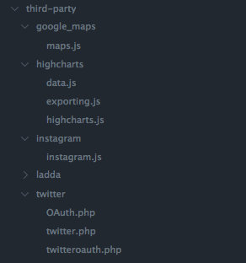

**Handles.Js File**

**This snippet of code represents dynamic call to server using Ajax technique. It allows for retrieving the data for form asynchronously in the background while user enters details of his sign in form. The function is called when user enters the user name and password for his account and the results are used to inform him that he is already signed in or signed up. Using the php framework I created.**

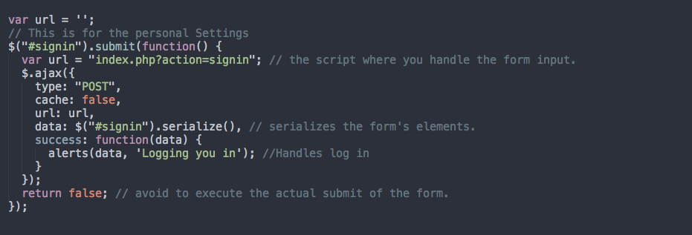

The below function is called after the submission is sent to the php code and is used to alert the user of the feedback.Presented example shows use of JavaScript functions to manipulate the HTML elements in reaction to user behavior. It includes use of standard DOM methods of accessing nodes in the document as well as jQuery built in enhancements for visual effects. By using client side scripting I was able to provide dynamic functionality that would be impossible to achieve or would require additional interaction with server side scripts.

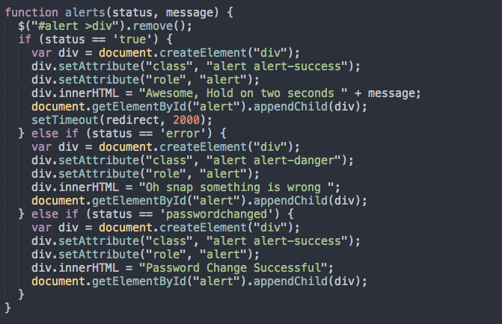

Php and my sql

The Model-View-Control (MVC) pattern, originally formulated in the late 1970s, is a software architecture pattern built on the basis of keeping the presentation of data separate from the methods that interact with the data. In theory, a well-developed MVC system should allow a front-end developer and a back-end developer to work on the same system without interfering, sharing, or editing files either party is working on.

So I decided to try and build my own mvc framework.

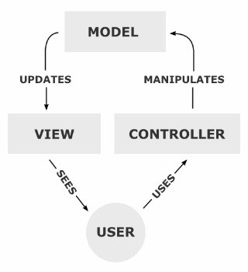

As seen on the diagram on the right, it allows me to work on different parts of the website

alongside each other. I hosted the website on Github to allow for comments and bugs alerts.

Created folder structure is as follows:

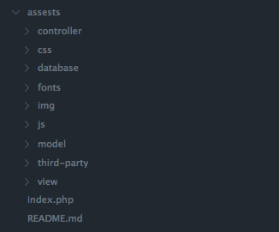

The example below represents the snippet of code from the controller class. It shows the structure of how the application responds to user’s actions in terms of navigation. It checks the the value of session variable to recognise that user is logged. It also redirect content to be displayed depending on values passed to attributes in the browser’s address bar.

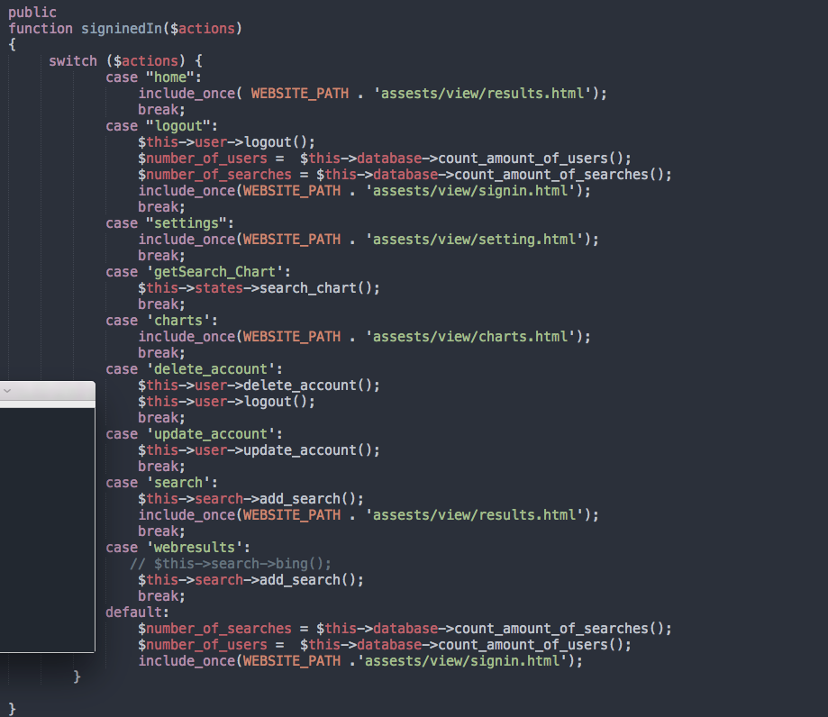

Mysql

For the application to be able to store information I had to support it with database. I decided to use MySQL that is shipped in package together with apache HTTP server. This was a convenience for me because if i were developing my application on local machines and also this is the package that I are the most familiar with. I developed a database called Project’ that contained set of tables presented below:

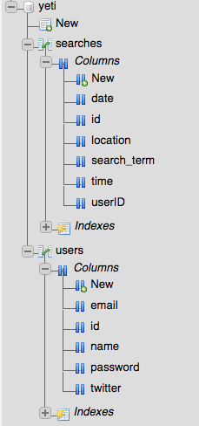

Reacting to user input involved use of using wide range of SQL statements: INSERT, UPDATE, DELETE and SELECT. For the most of the time I was operating with simple queries where given values were passed into database to be stored/updated or used for deleting/retrieving some information. There were few SQL queries with more complicated structure. Example of it is shown on the picture below. It represents two table join statement that pulls information from users and searches.

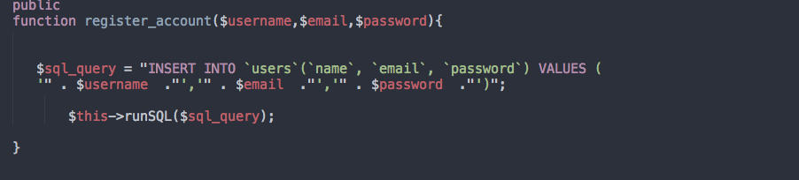

EXTERNAL CODE IMPLEMENTATION

What is an API?

An Api allows a software application to communicate with a remote application over the Internet through a series of calls and responses.

With APIs, the calls back and forth between applications are managed through something called Web services. Web services are a collection of technological standards and protocols, including XMLor in Json , the programming language by which applications communicate over the Internet.

What are the BING api ?

What are the Google Api

What are the ingratam api ?

What are the duckduckgo ?

Highcharts

Highsoft AS is the company behind Highcharts JS, the JavaScript charting engine, and Highslide JS, the image and media viewer. Highcharts has quickly become one of the industry leaders in standards compatible, JavaScript based charting.

How did I use it ?

I use it in the displaying of information for the graphing system so users can track process in a great style and use. This can be seen in the grapht section of the website.

Highcharts

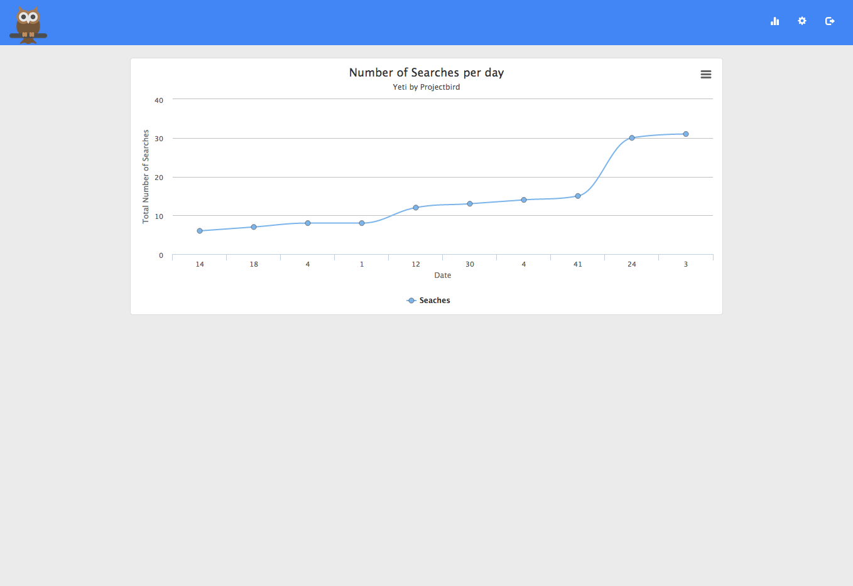

Evaluation

Evaluate your deliverables

In this section i will discuss the have i completed what i set out to complete. This vital part of the documentation .

Login and signup Completed 100%

Here i reached the goal of recording users that log on and off on the website. This function was successfully implemented to the way i wanted. Its a handy way of recording which people use the site.i have also reached the goal of creating a signup page which allows the user the create a username and password to log into the site.

Database

In this part i had to make a database that stored all the results of the search and the usernames and passwords of what is searched. Here they were a few faults that if i had a bit more time i would have improved. Such as having no password encryption. The passwords are in plain text in the in the database table. If i had more time i would have implemented password security into to make everybodies password more secure.

Search

The main feature of course was the search aspect of the website. This was 100% successful and worked to the ability of of the deliverables that i had to do.

The search aspect

Search Bar

Statistics Page

Settings

Posting to twitter

Search Organising

Evaluation

Summarise testing procedures (+ relevant testing results)

Evaluate your deliverables (how successful was the project?)

Suggest future enhancements

Conclusion and future extensions

Say what you’ve concluded from doing the work and how you’d build on it

# **Appendix**

# **Code Reference List**

## Bootstrap

Bootstrap is a free and open-source collection of tools for creating websites and web applications. It contains HTML- and CSS-based design templates for typography, forms, buttons, navigation and other interface components, as well as optional JavaScript extensions

It takes care of most if not all the css issues allowing my project to work across muipty deivices and screens

The overall physical design of the website was done with Bootstrap. Boot strap is a very handy tool that is used as boot strap. Bootstrap is a relatively new system in the last couple of years it makes everything clean and professional. Below is a description of what Bootstrap say it is below that have are the links of which i learned of the design with bootstrap.

<http://www.w3schools.com/bootstrap/>

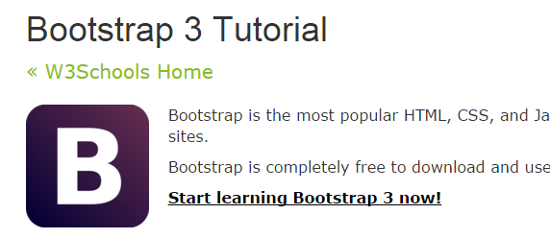

<http://www.tutorialrepublic.com/twitter-bootstrap-tutorial/>

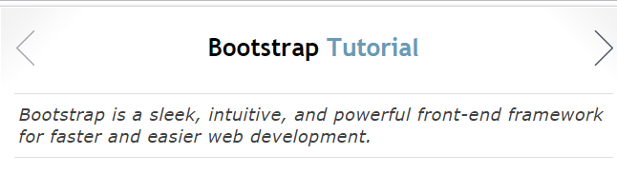

<http://getbootstrap.com/getting-started/>

**folder structures**

I learned in my server side web development how to structure php properly and what the best practices are

But for improvement on the best coding practices . Also on how to structure the folders in the right way i used and which makes sense i referenced many articles but i the one referenced below is the best one i found.

About design best practices, let's share our views about naming and structure used (including some obvious design patterns) For example, let's imagine a small module for zipcodes, where we have a world wide DB of zipcodes and we are going to build a module out of it, to be reused in many projects.

How would you approach the following issues?

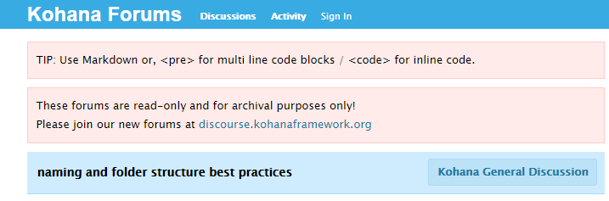

<http://forum.kohanaframework.org/discussion/9133/naming-and-folder-structure-best-practices/p1>



<http://www.warmforestflash.com/blog/2009/10/folder-structure-and-project-organization-best-practices/>

**Ajax/ Handle**

Ajax was used for making sure that when the user inputs data in the search bar it stay on the same page and doesn't redirect to a different page.

*“Good day im am trying to send or get data from a form and then using jquery and then ajax to send the data into a php page that should save it in the database how can i do it in jquery and use ajax to do it, any help will do and thanks!”*

[*http://stackoverflow.com/questions/19029703/jquery-using-ajax-to-send-data-and-save-in-php*](http://stackoverflow.com/questions/19029703/jquery-using-ajax-to-send-data-and-save-in-php)

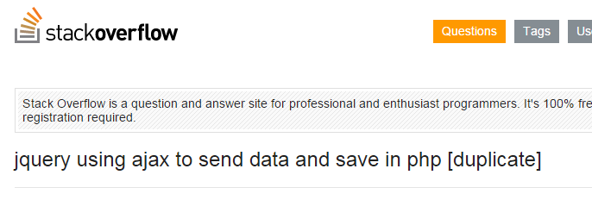

***Handles file***

The javascript file called handles.js in the js folder is for handling all the form submissions, were information is passed between the user to the server. This is achieved using jQuery to capture the form submission and the information the user sends. It then sends that information to the php controller which run the function we built . An example of this is var url = "index.php?action=signin" were the text in red is the function we want to call. In the php controller it will do this switch ($actions) { case "signin": $this->user->sign_in(); break;

As you can see, we can change that red text to signup and it will run the function for sign up. In the php code there is function I wrote to check if there signed in, and more . That if there information there sending is incorrect the php will send back a false boolean value. This is done for everything to make sure there is error handling.

So it will display the user a error and to let them know what is happening. Going back to the handles.js file. it then uses the ajax to send the information and if the code is success run on the php side it will run the function inside the success.As seen below the the data is being serialized( In computer science, in the context of data storage, serialization is the process of translating data structures or object state into a format that can be stored).

Below is for signing int and letting the user that they are being signed in and is calling another function that displays the message. // This is for the personal Settings $("#signin").submit(function() { var url = "index.php?action=signin"; // the script where you handle the form input. $.ajax({ type: "POST", cache : false, url: url, data: $("#signin").serialize(), // serializes the form's elements. success: function(data) { alerts(data,'Logging you in'); //Handles log in } }); return false; // avoid to execute the actual submit of the form. }); In another case in the handles.js file there is times i need to call javascript files for different apis.

like for instrgam.

In the snippet below is using a jQuery function to call and include a another file javascript and run a function. in the example below I'm including the instagram file in the third party folder. and running the grab images function in that file. success: function(data) { $.getScript("http://localhost/yeti/assests/third-party/instagram/instagram.js", function(){ grabImages(jQuery("#search_bar_input").val(), 4, access_parameters); }); }

As you can see the handles .js file int he most import file in the project as it handles the apis calls to the servers and at the errror handling.

**javascript createelement (alerts)**

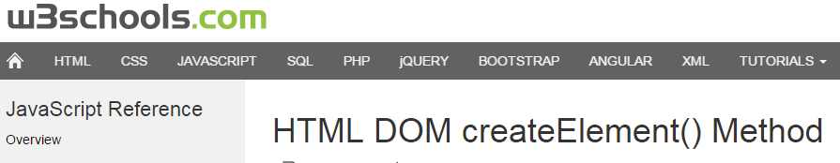

<http://www.w3schools.com/jsref/met_document_createelement.asp>

**Apis**

I had to get apis for certain services for search aspects. i will not list below the apis of the that i used and where i got them from.

Google

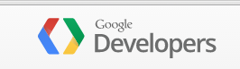

<https://developers.google.com/web-search/docs/>

Bing

This is how to use the bing api for searching.

<http://stackoverflow.com/questions/12789355/bing-search-http-request-with-json-result-example>

<http://www.bing.com/developers/s/APIBasics.html>

here is where i got the api

<http://www.bing.com/dev/en-us/dev-center>

Go Go duck

This is where i learned how to use the go go duck api and managed to get it working.

<https://duckduckgo.com/api>

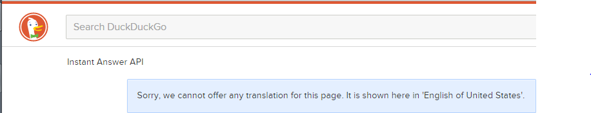

In the handles folder on how to post the twitter

This is seen in the setting page

<http://www.tech-faq.com/send-tweets-to-your-twitter-account-via-php.html>



Highcharts

I used highcharts for the statistics page in the project. I found a third party piece of software that can be used for this Its called Highcharts i learned to put it in from there handy demo on there website.

Highcharts is a charting library written in pure JavaScript, offering an easy way of adding interactive charts to your web site or web application. Highcharts currently supports line, spline, area, areaspline, column, bar, pie, scatter, angular gauges, arearange, areasplinerange, columnrange, bubble, box plot, error bars, funnel, waterfall and polar chart types.



<http://www.highcharts.com/docs/getting-started/your-first-chart>

<http://www.highcharts.com/demo>

**Ladda Buttons**

This is a third party piece of software for the website.

https://github.com/hakimel/Ladda

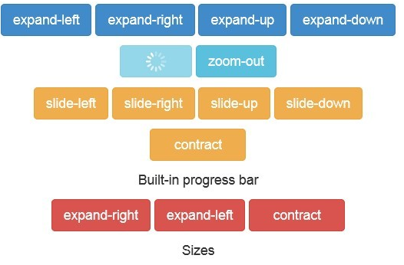

**Additional references**

<http://www.w3schools.com/php/php_cookies.asp>

<http://php.net/>

<http://www.sqlcourse.com/table.html>

<http://www.w3schools.com/Ajax/ajax_intro.asp>

<http://www.phptherightway.com/>

Project management

Bibliography